**The differences between KFC and McDonald’s**

*Jack 1930026143 1018*

Content

1 The history 2

1-1 KFC 2

1-2 McDonald’s 2

2 Development in Hong Kong 2

2-1 KFC 2

2-2 McDonald’s 2

3 Social Responsibility 2

3-1 KFC 2

3-2 McDonald’s 3

4 Restaurant Design 3

# 1 The history

## 1-1 KFC

Every day, more than 12 million customers are served at KFC restaurants in 110 countries around the world. KFC's menu everywhere includes Original Recipe chicken – made with the same great taste of the secret blend of 11 herbs and spices Colonel Harland Sanders created more than half a century ago. Customers around the globe can also enjoy more than 300 other products – from buffalo wings in the US to cod fish burgers in China.

KFC is part of Yum! Brands, Inc., the world's largest restaurant company in terms of system restaurants, with more than 36,000 locations around the world.

Today, the Colonel's spirit and heritage are reflected in KFC's brand identity — the logo features Colonel Harland Sanders. It is one of the best-recognized icons in the world.

## 1-2 McDonald’s

Can you imagine a world without McDonald's Fries, the Big Mac, the Filet-O-Fish, or the Happy Meal?

Luckily, in 1954, an enterprising salesman named Ray Kroc discovered a small burger restaurant in California, and wrote the first page of McDonald's history. From that humble start as a small restaurant in Des Plaines, Illinois in 1955, we’re proud to have become one of the world’s leading quick service restaurant, with more than 33,500 restaurants serving nearly 68 million people in more than 119 countries and areas every day.

# 2 Development in Hong Kong

## 2-1 KFC

KFC arrived in Hong Kong in 1985. KFC (Hong Kong) is a franchise, managed by Birdland (Hong Kong) Limited since 1997. KFC (Hong Kong) has over 60 branches throughout the territory with a team of more than 3,000 employees and serves over 1.5 million customers each month. Of the menu offered, the Original Recipe, Hot & Spicy, BBQ Honey Wings, Zinger Burger, Mushroom Rice and Egg Tart are the most popular KFC tastes.

## 2-2 McDonald’s

In 1975, the first McDonald's in Hong Kong opened on Paterson Street, Causeway Bay. We've strived to be our customers’ first choice, and their favorite place and way to eat. Today there are around 235 McDonald's Restaurants in Hong Kong, employing more than 15,000 McDonald's staff. And we are committed to offer a pleasant dining experience to every customer.

# 3 Social Responsibility

## 3-1 KFC

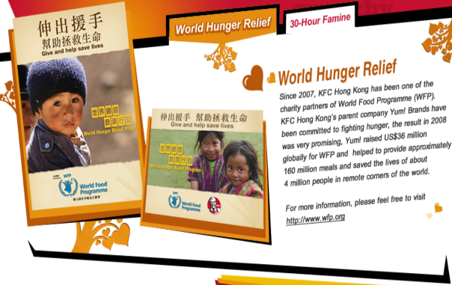

Figure 1World Hunger Relief

## 3-2 McDonald’s

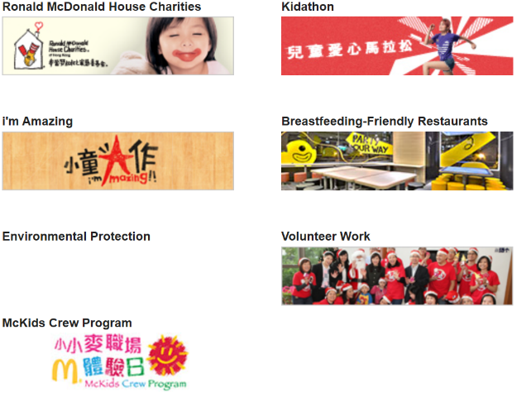

Figure 2 Sustainable Community Building

According to the comparison, it’s clear that McDonald’s has more social responsibility than KFC.

# 4 Restaurant Design

McDonald's Keep coming up with new ideas, create specific atmospheres and moods to deliver a differentiated and Provide customers with refreshing designs

* A little goes a long way. The Minimal concepts can now be experienced at the McDonald's Restaurant located at Plaza Hollywood in Diamond Hill.
* Freedom and moments. The Form & Allegro concepts can now be experienced at McDonald's Restaurants located at Sha Kok and Courtyard by Marriot in Sha Tin.
* My time, my space. The Public & Hub Metro concepts can now be experienced at McDonald's Restaurants located at Hillwood Road in Tsim Sha Tsui and Johnston Road in Wan Chai.

On the other hand, the above three points are generally combined in a KFC restaurant.